PURCHASE ORDER / RECEIPT LOGIC FOR OUTSIDE SHEETING

The purchase order type “S” for sheeting is to cumulate the total cost of board to include both the original cost of the board material, plus the cost to convert the board material into sheets. This logic is used when buying board material from one vendor, then sending the material to another vendor to convert the board material. This modification was written to purchase paper rolls from one vendor, then have another vendor create sheets from the rolls. However, a box plant could send sheets to one vendor and drop ship the sheets to another vendor to sheet, cut, score and finish. The board may then be sent back to the box manufacturing and received as material, then issued to the job.

New Purchase Order Type called "S" for Sheeting PO. The Purchase Order will work as any other Purchase Order, but the PO type will trigger new logic in raw material receipts and raw material issues.
Job 208491 requires SBS18 board with a sheet width of 24.5 inches and a length of 25 inches.

1) First purchase order for rolls such as SBS18-24.5 as Normal or Drop Ship to outside vendor. Please note, no Job number is requited on the purchase Order to the Vendor. This logic assumed that this would be for real stocked roll or sheets, no Job# on the Purchase Order. For example this could be PO 102888 for 40,000 LF at cost of .25 per LF will be received into inventory.
2) Raw Material Receipt for the first purchase order for Rolls or Sheets into inventory. This puts the real cost of the paperboard into the History and Bin Files. The cost of .25 per roll (the unfinished/unconverted material) will be stored in the M-F-1 Bins File and displayed in the History Tab.
3) A second purchase order (PO Type = S) for the Job 208491 (PO# 102890) for converting rolls into sheets or other conversion is entered for 20,000 Sheets at cost of .10 per each sheet. This second purchase order will require a new real material item such SBS18-2425 which is a sheet size of 24.5 x 25 inches. Please note, the JOB# is not required on the PO because the RM Item has the Sheet Length that is needed for calculating the total roll cost into the sheet cost. The cost on the seheeting purchase order is just for the cost of conversion, a cost of .10 per each sheet or cost per one thousand, entered as per M. The purchase order quantity would be the total number of sheets that should be converted. However, this quantity may change when sheets are received. In this example, we would only produce 19,200 sheets based on the rolls 40,000 Lineal Feet x (Jobs Length of 25 Inches / 12 Inches).

4) M-U-2 Raw Material Issue. This stores the Rolls Cost. Click M-U-2 and Click Add, type the conversion PO# 102890 into the purchase order field, leave the job number blank and enter the Roll’s raw material part numbers used on the PO number 102888 for the purchased rolls which were consumed during the sheeting process by the outside vendor. Enter the total lineal feet or number of sheets including waste converted by the outside vendor. This will reduce the on hand quantity of the rolls that were originally purchased then shipped to vendor. The quantity issued will also store the cost of the roll which will be added to the cost of the sheeting PO when receiving the Sheets from the Sheeting PO. The cost of the roll will be imported from the bins file for that roll tag. When the issue transaction is posted, the Issue will be displayed on the M-F-1 Transaction History for the Roll material without a Job#. Please note, the cost of the roll may include freight cost and may be an average cost if roll tags are not used.

5) M-U-1 Raw material Receipt for the new Sheets Part Number from PO# 102890. Type the second Purchase Order number 102890 for the converted sheets. The cost will combine the cost of roll and cost for conversion such as sheeting and freight from the second purchase order PO# 102890 will be combined. The receipt quantity will be the net quantity of sheets converted. In this example, we would receive 19,200 sheets which equals 40,000 LF of the rolls. The roll cost was .25 per LF and the job required 25 inches per sheet. Therefore the rolls cost per sheet = $.5208 Calculated as Job Length of 25 inches /12 x $.25 Add $.10 for sheet conversion and the total cost per sheet = $ .6208
6) Issue sheet item SBS18-2425 to Job 208491. This will reduce the on hand quantity of sheets and also transfer the cost of the sheets to the jobs work in process costs. The $11,919.36 cost ($.6208 x 19,200 sheets) will be applied to job 208491.

SHEETING PO SCREEN

First, create a new Board Code for the Sheet with the Sheet Size Defined.

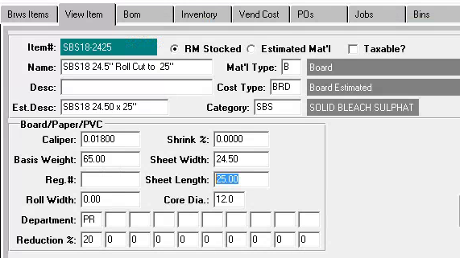

Then Create a PO with PO Type = S and Enter the new Sheet Item on the PO Line with the Cost for Conversion.

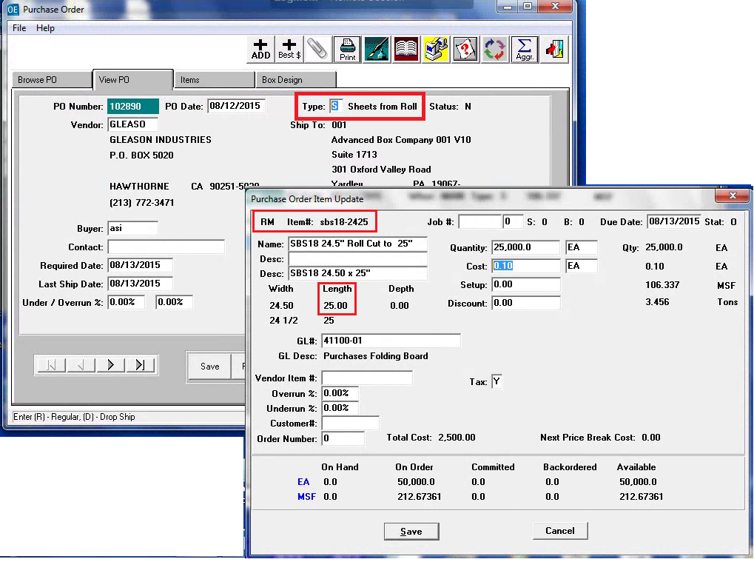

ROLL STOCK SBS18-24.5 TRANSACTIONS

On PO# 102888, I received 1 roll and 1 blank tag. Then Issued both to PO# 102890.
Notice that the ISSUE transactions done on M-U-2 for the sheeting PO# 102890 has the cost of the roll.
This cost is added to the cost of conversion when the Sheets are received.

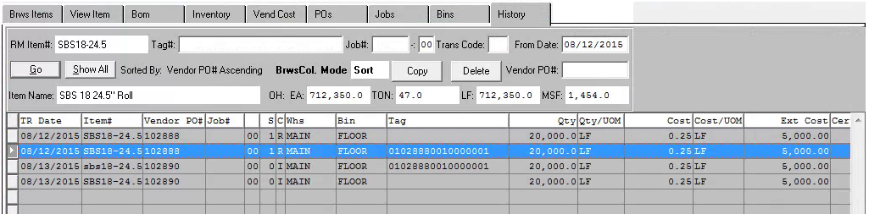

SHEET STOCK SBS18-2425 TRANSACTIONS

On PO# 102890, I received 19,200 Sheets
User can receive 19,200 sheets without a Pallet Tag.
Or User can receive Pallet Tags that total up to 19,200 sheets.
Note the cost is the combined cost of $.10 for sheeting conversion plus cost of rolls LF per Sheet.
That is $.10 + $.520833

